UN Food and Agriculture Organization


AOS Registries:
Assessment & Strategic Directions
Draft

Submitted by
Information International Associates, Inc.
Oak Ridge, Tennessee

Draft March 31, 2010

Table of Contents
1.0 Introduction 5
2.0 Background 5
2.1 AOS Content 5
2.2 AOS Services 5
3.0 Registry Architectures 6
4.0 Use Cases for Managing Vocabularies and Maintaining Registries 7
4.1 Use Cases for Managing Vocabularies 7
4.2 Use Cases for Terminology Registries 7
4.2.1 Description and Announcement 7
4.2.2 Acquisition and Publishing 8
4.2.3 Creation, Modification and Maintenance 8
4.2.4 Support Metadata Creation 9
4.2.5 Support Search & Retrieval 10
4.2.6 Integrate Vocabularies 11
4.2.7 Archive and Preserve Vocabularies 11
5.0 Other Registries 11
5.1 NCBO BioPortal 11
5.2 National Science Digital Library (NSDL) 13
5.3 US Environmental Protection Agency Terminology Registry 16
5.4 Global Biodiversity Information Facility 18
5.5 OCLC Terminology Services 20
5.5 Library of Congress 20
6.0 Related Initiatives 20
6.1 JISC Terminology Registry 20
6.2 DC-NKOS Application Profile 21
6.3 Ecoinformatics Ecoterm Working Group Efforts 21
7.0 Vision for the AOS Registries 21
7.1 Short-Term Future 21
7.2 Longer-Term Future 22
8.0 Recommendations 22
8.1 Establish a Clear Distinction Between the Repository and the Registry 23
8.2 Establish Web Services at the Vocabulary and Term Levels 23
8.3 Extend the RSS Feed to the Term Level 23
8.4 Arrange for Search Engines to Index the AOS Content 23
8.5 Enable Linked Open Data and voID Files 23
8.6 Affiliate the AOS with Other Registries 24
8.7 Use Open Source Software 24
8.8 Provide Collaboration Tools and Services 24
8.9 Perform Usability Testing for Both General Users and Developers 25
9.0 Next Steps 25
APPENDIX A: Web Services 26
APPENDIX B: Metadata Analysis 28
References 29

1.0 Introduction
This report is provided as a deliverable under a Personal Services Agreement to assess the FAO registries, compare them to similar enterprises, and make recommend strategic directions for the future.

The report begins with background, setting the scope of the work as developed in the Kick –Off Meeting on February 28, 2010. This section is followed by a general discussion of the functionalities and services that are related to vocabulary registries (both terminology/ontology and application profiles/schema). Several exemplar systems are then described followed by a vision for the AOS of the future. This section is then followed by specific recommendations for next steps that are in line with the vision.

2.0 Background
Since 2001, FAO has developed a set of registries for vocabularies, data-schemas, thesauri and ontologies under the general umbrella of the “Agricultural Ontology Service” (AOS). These registries are part of the Agricultural Information Management Standards (AIMS) web site and are used by agricultural information managers world-wide. While the content in the AOS has grown during this period, the functionality and services have remained essentially the same. The services, particularly machine-to-machine are limited. In addition, there have been changes in the approaches to terminology/ontology services in general, and registries in particular, which should now be considered as FAO looks to the future of the AOS.

2.1 AOS Content

At the moment AOS has three components -- Agrovoc, agriculture-related knowledge organization systems/ontologies, and application profiles (APs) or data exchange formats. As noted above, this assessment focuses on the ontologies and the APs and does not include Agrovoc.

The KOS Registry and the AP Registry contain content that is simply registered, i.e., descriptive metadata and a URL are provided, and content that is maintained by FAO. In this case, the content is both registered and available in a repository directly from FAO. The majority of the content that has been contributed is in the form of Access files so there is no consistent schema. Updates are very seldom made to the application profiles. The ontologies are updated more often; they are updated outside the system and then uploaded.
There is a registry on top of this content with a consistent metadata schema that describes each resource. However, it should be noted that while the URLs are provided for external resources, the links are not active. Particularly in the area of the profiles, the AOS distinguishes between those which are recommended and those for which they are merely caretakers. This is a metadata issue that must be retained.

2.2 AOS Services

The majority of the service development to-date has been around Agrovoc, including the development of the Concept Server and the Workbench. These services are heavily used. The services for the APs and the ontologies are more limited. The APs can be browsed and downloaded as OWL files. The ontologies can be searched by topic and ontology type (or a combination of these two factors). The results can be downloaded as OWL files. RSS feeds are also available for the KOS-All, allowing users to sign up for news about new versions and new resources.

Since the majority of the resources are pointed to rather than deposited, the ability to search resources is limited and there is no ability to search across resources. Ultimately, the majority of the services depend on the functionality provided by the native web sites for the resources.

3.0 Registry Architectures
Golub and Tudhope identify three basic registry architectures which develop from the services and functionality described in section 3.0 above.
- The registry contains only metadata for the KOS
- The registry contains metadata and points to third-party terminology services
- The registry becomes a repository in which the content (in whole or part) is stored within the repository
The services that can be provided are dependent upon the architecture selected. However, the complexity of the registry also increases as the architecture moves from option 1 to 2 to 3.
In Option 1, the registry is a catalog and is, therefore, concerned primarily with collecting and maintaining a consistent set of metadata for each KOS. This is the current architecture for much of the AOS. Key questions include the scope of the registry, appropriate categorization schemes and pick lists to ensure consistent completion and validation of metadata, and appropriate search, browse, and navigation to present the metadata via the Web. While there are concerns about the currency of the information, there is usually little change in the metadata and the link to the current version of the content on the owner’s web site provides back-up if the information becomes dated.
In Option 2, the registry takes on more functionality. The registry not only provides metadata but access to third party services that may display, search or visualize one or more KOS. Because links to these terminology services must be maintained, there is an added responsibility for consistency and currency.
Option 3 imposes the most responsibility on the registry since it not only points to the content, but ingests or imports the content. The registry maintains the data, either through periodic imports or by providing services that allow the owners to update the vocabulary. Issues of quality control, format (including various data models) and version control become paramount. The registry provides services, often for a partnership of terminology owners/developers. These services may include search, browse, mapping, visualization, publication, collaborative development and consistent machine-to-machine web services across the hosted terminologies.
A potential fourth option that represents a much more futuristic architecture than any of those identified by surveying current implementation involves the provision of terminology services in the cloud. This approach could potentially allow the content to remain under the control of the owner/publisher with the terminology services are provided as virtual applications on the Web.

4.0 Use Cases for Managing Vocabularies and Maintaining Registries
Before evaluating the specifics of the AOS environment, we step back and discuss the use cases for managing vocabularies in the first place and then use cases for registries, in particular. An understanding of the rationale for developing registries should be considered as AOS considers its future.

4.1 Use Cases for Managing Vocabularies
The use cases for managing vocabularies, including ontologies, APs, and schemas of various types are well documented in the “Terminology Services and Technology: JISC State of the Art Review” (Tudhope, et al, 2006). The authors identify four general use cases for managing vocabularies.
- Retrieval performance – the Terminology Registry suggests additional terms to construct or refine a query with the goal of improving performance (recall and precision)
- Name authority – a common name of a person or organization would be aided by the addition of other forms (including historic) of the name to expand the search or aid in disambiguation of names
- Mapping and other Terminology Services – combining a classification scheme with a thesaurus for indexing
- Repositories – Terminology Services augment the general classification with an entry vocabulary of synonyms and search of this extended vocabulary enhances retrieval

4.2 Use Cases for Terminology Registries
At the next level it is helpful to look at the use cases for terminology registries. The following set of use cases and related system functionality was developed from a number of sources including “Terminology Registry Scoping Study: Final Report,” (Golub & Tudhope, 2009), “Terminology Services and Technology: JISC State of the Art Review,” (Tudhope, et al, 2006), “Knowledge Organization Systems in Digital Libraries: Beyond Authority Files (Hodge, 2000), and Networked Knowledge Organization Systems (NKOS) work on registries. The Golub and Tudhope report provides the results of a survey of use cases among registry owners and experts. This is the most comprehensive assessment of use cases and functions; however, there is much duplication across the categories. Therefore, this section reorganizes that information, presenting a model for thinking about possible functionality in the FAO context.
Just as with the FAO effort to-date, JISC found that the most frequent use cases identified in its scoping study was the use of a terminology registry to discover and examine vocabularies in a particular subject domain when planning or building a repository or digital collection. This functionality is already covered by the current AOS, though we will make some observations about improvements that could be made to the current functionality.

4.2.1 Description and Announcement
At the most basic, registries describe and announce the existence of relevant vocabularies. The most basic registries are a simple page of links that provide the name of the resource and the URL. More advanced registries are catalogs of resources, which incorporate descriptive and, perhaps, technical metadata that describe the vocabulary. These registries let people know that a vocabulary exists, support evaluation and provide indirect access to the content through a link to the publisher/owner’s web site.
The central web site and consistent description serves the user by providing a one-stop look up for relevant resources, whether application profiles or terminology/ontology resources. The focus of these registries is to allow users to discover relevant resources, often with the goal of applying the content to a particular physical or digital collection.
The following functions are required to serve this purpose:
- A method, whether human or machine supported, for identifying relevant vocabularies
- Development of a consistent web page design or metadata scheme
- A database, spreadsheet, or content management system to support the collection and validation of metadata
- Routine link checks to ensure that broken links are addressed
The current AOS focuses heavily on announcing the availability of relevant vocabularies. Its registry provides consistent metadata about each KOS or AP. URLs are provided to the native web sites, but these URLs are not live links. This eliminates the problem of broken links but makes access to the vocabularies even less direct for the user.

4.2.2 Acquisition and Publishing
Registries may acquire and publish vocabularies from a particular publisher, enterprise, or a field or domain.
The following functions are required to serve this purpose:
- Purchase licenses for making full vocabularies available to registered users
- Allow viewing of vocabularies to registered users
- Ensure easy user registration process (e.g., via IP without password)
- Allow viewing of vocabularies to registered users before buying
- Provide export/download of whole vocabularies
- Provide export/download of parts of vocabularies
- Provide export/download in a variety of standard formats
- Provide web services for accessing individual terms and concepts of use to, for example, topical crawlers

The AOS does not acquire or publish external vocabularies, so it is not concerned with user registration or licensing. It does publish ontologies and APs that it maintains. Of the functions described above, the current AOS provides export/download functions but it does not provide web services for machine-to-machine access.

4.2.3 Creation, Modification and Maintenance
Registries may become repositories with the addition of the content and functions to create, modify and maintain the vocabularies they contain. These use cases focus on the content of the individual vocabularies or subsets, making additions or changes to existing vocabularies, and sharing or publishing new versions. Such a registry/repository may be developed to support the following use cases:
- Managing local terminologies
- Establishing a project-specific subset of terms
- Joint editing and annotation of local terminologies by experts
- Contributing to a published terminology
- Capturing locally contributed end-user terminology
- Sharing local terminologies
A registry undertaking these services may provide some or all of the following functionality:
- Vocabulary registration and upload
- Submission of metadata for submitted terminology
- Validation of submitted terminology
- Validation of metadata for submitted terminology
- Provide URIs for each vocabulary
- Editing
- Revision and extension
- Tracking and versioning
- Submission of new versions
- Collaborative support services (e.g., discussion board, wiki)
- Tracking who the users are
- Allowing vocabulary users’ registration and signing up for regular, configurable notification of changes in the vocabularies they use
- Providing best practices for vocabulary development and management, for example, a road map of how to reuse existing vocabularies and their member terms/classes in future constructing of a new vocabulary

These functionalities require an infrastructure of terminology management that goes beyond the registration of a vocabulary and the collection of its metadata. These functions encompass much of the functionality performed by thesaurus, schema or ontology management software products, such as version control, terminology-level metadata, and providing business rules and processes that ensure quality output at the term level.

FAO currently undertakes these services and functions only for ontologies and APs directly maintained by FAO, such as AgMES, the AGRIS AP, and Agrovoc. However, the functionality is not within the AOS Registry system, but external to it.

4.2.4 Support Metadata Creation
Registries may provide support for the creation of metadata including:
- Metadata validation
- Browsing, searching and retrieving terms
- Automated controlled term suggestions

This approach is particularly useful if the cataloging tool can be tied very closely to the registry, such as with Agrovoc, or if the vocabulary is to be used by a variety of third-party metadata creation tools.
More specific services and required functionalities include:
- Provide services for browsing, searching and retrieving controlled terms to professional cataloguers
- Provide services for browsing, searching and retrieving controlled terms to social taggers
- Provide services for validating names and controlled terms in metadata including a spell-check service
- Provide links to related standards
- Provide automatically generated controlled terms (links to machine aided indexing)

These use cases are met by the individual vocabularies housed in the AOS and in particular by the Agrivoc Concept Server and Workbench. However, these services are not generally provided for other APs or ontologies.

4.2.5 Support Search & Retrieval
Registries that contain one or more vocabulary repositories can support search. They can be used directly by end users to identify terminology to be used or the terminology can be leveraged machine-to-machine to optimize search.
The following functionalities are required:
- Allow searching and browsing of terminology services metadata
- Provide service access details for terminology services (how to connect)
- For each KOS, provide KOS identifier and version identifier and cross-walk data
- Allow searching and browsing of vocabularies by end-users
- Allow services that identify synonyms to automatically expand search for users
- Allow services that provide hierarchies and other semantic relationships to automatically expand search for users
- Allow services that offer the ability to search across multi-lingual repositories
- Allow services to support disambiguation and cross-disciplinary searching (via mappings)

In the case of the APs and ontologies that are not held as content, these search functions are more likely to be addressed by the native web site for each vocabulary. The user may identify that web site via the announcement service of the current AOS, but the actual identification of relevant search terms cannot be performed within AOS.

The vocabularies that are held as content in the AOS can be browsed or searched manually to identify terms for searching. Since none of them, except Agrovoc has web services available, it isn’t currently possible for a search engine to leverage terminology in any of the vocabularies in order to automatically optimize search.

4.2.6 Integrate Vocabularies
A relatively new use of registries is as a system for creating, storing and annotating the mappings between vocabularies. The use cases focus around the need to search different collections using “one” vocabulary, the need to assign terms from multiple vocabularies to an interdisciplinary collection without creating another vocabulary resource for this purpose, and the desire to combine local, shared or published terminologies within the same or across disciplines either to support the same enterprise or partnerships.

The functionalities required to achieve the integration focus on merging and mapping.

- Provide services for (semi)-automated merging and mappings between vocabularies (e.g., data mining techniques, co-occurrence-based techniques)
- Provide services with intellectual merging and mappings between vocabularies
- Provide tools for comparing multiple vocabularies and producing merging and mappings between vocabularies
- Provide above for merging and mappings between end-user vocabularies (including social tags) and published vocabularies

AOS has developed some mappings which are available from the AOS. However, the mappings themselves have been created outside the AOS environment and then the resulting products have been provided as independent resources.

4.2.7 Archive and Preserve Vocabularies
Some registries are also concerned about archiving and preserving vocabularies for future use. This is particularly true for significant vocabularies in a particular field where the publisher may no longer be able to provide the resource. This service requires much the same functionality as above, with some possible extension to the metadata and particular attention to issues of the data model and long-term format.

5.0 Other Registries
There are several other vocabulary registries that have been developed in support of particular projects, communities of interest or discipline areas, or as research projects. This section describes these other registries. (Additional information about many of these registries and information about other registries may be found in Golub & Tudhope, 2009.) Subsequent sections will refer to these registries, comparing the functionality of the AOS and suggesting new functionality.

5.1 NCBO BioPortal
The NCBO BioPortal (http://bioportal.bioontology.org/) provides access to, sharing of and services surrounding ontologies that are used in the biomedical community. It is based on the open ontology project at Stanford University. The current version if Bioportal 2.2.2 which was released on February 2010. The NCBO BioPortal currently includes 193 ontologies, containing almost 1.5 million terms. It also provides access to resources that have been tagged using these ontologies.
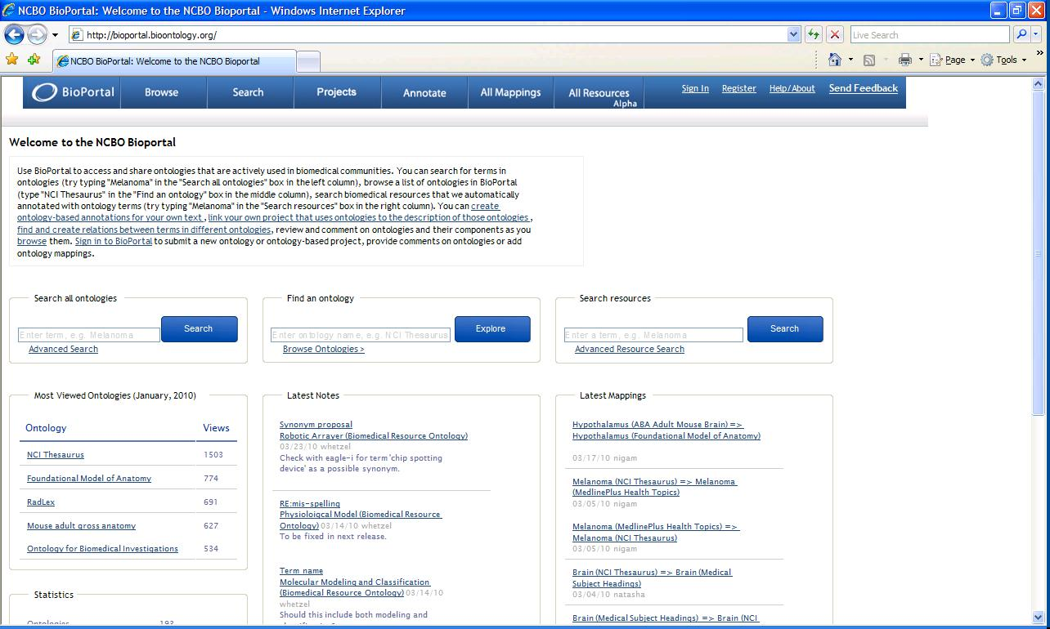
Users can search for terms across the ontologies, browse a list of the ontologies in the BioPortal and search biomedical resources that have been automatically annotated with the ontology terms. Several mappings are also included in these resources. The content of ontologies or ontology components can also be browsed.
Other services include creating ontology-based annotations for text, linking projects that use one of the ontologies to the description of the ontology, finding and creating relations between terms in one ontology and another, and reviewing and commenting on ontologies. A special sign-on is needed to add content to the portal.
Functions supported by the Bioportal include: deposit of ontologies, maintenance, descriptive metadata and registration, downloading in whole or part, visualizing in several ways, RSS feeds, aligning and integrating across ontologies, and bookmarking a concept.
BioPortal supports ontologies in OBO, OWL, RDF, Rich Release Format (RRF) which is used for the Unified Medical Language System, Protégé frames, and LexGrid XML (used by the Mayo Clinic and the National Cancer Institute). The Protégé Patch Release 3.4.2 is necessary to make Protégé compatible with this latest version of Bioportal.
The NCBO BioPortal provides the most extensive array of web services of all the registries evaluated. In part this is because web services are provided for most functions available through the BioPortal web site as they come on-board. The web services are outlined in Appendix A. Of special note is the extensive number of web services that focus on versioning and the prototype services that are provided to the community for use and comment before they are finalized.
The Marine Metadata Initiative has taken the basic NCBO BioPortal software and enhanced it to meet the needs of its particular community. The enhancements include: The Ecoinformatics International Technical Collaboration (which includes the European Environment Agency, the US EPA, the EU’s Joint Research Center, and FAO) is considering the use of the MMI version as the basis for an environmental ontology portal.

5.2 National Science Digital Library (NSDL)
The NSDL Registry (http://metadataregistry.org/) provides a means to identify, declare and publish metadata schemas (element/property sets), schemes (controlled vocabularies) and Application Profiles (APs) through a registration process. In addition, the NSDL Registry supports the machine mapping of relationships among terms and concepts in these schemas (metadata crosswalks) and schemes (semantic mappings).
The Registry used as its inspiration the open-source Dublin Core Metadata Initiative (DCMI) Registry developed by OCLC. The NSDL Registry extended the original DCMI to include the automated creation and maintenance of schemas and application profiles, and the submission of schemas and schemes to a registry workflow for review and publication.
The NSDL Metadata Registry project was funded by the National Science Foundation for its first three years. It is currently managed by Metadata Management Associates, a consulting partnership committed to maintaining the Registry as an open system. The registry began as a project of the NSDL Core Team to collect and manage metadata schemes used by contributors to the NSDL digital library. It has grown significantly and now includes both metadata vocabularies and some controlled vocabularies. There are 96 resources from 46 contributors. Many of the resources are connected directly to the NSDL architecture and to the new RDA metadata. Some common schemas, such as FOAF, are also registered.

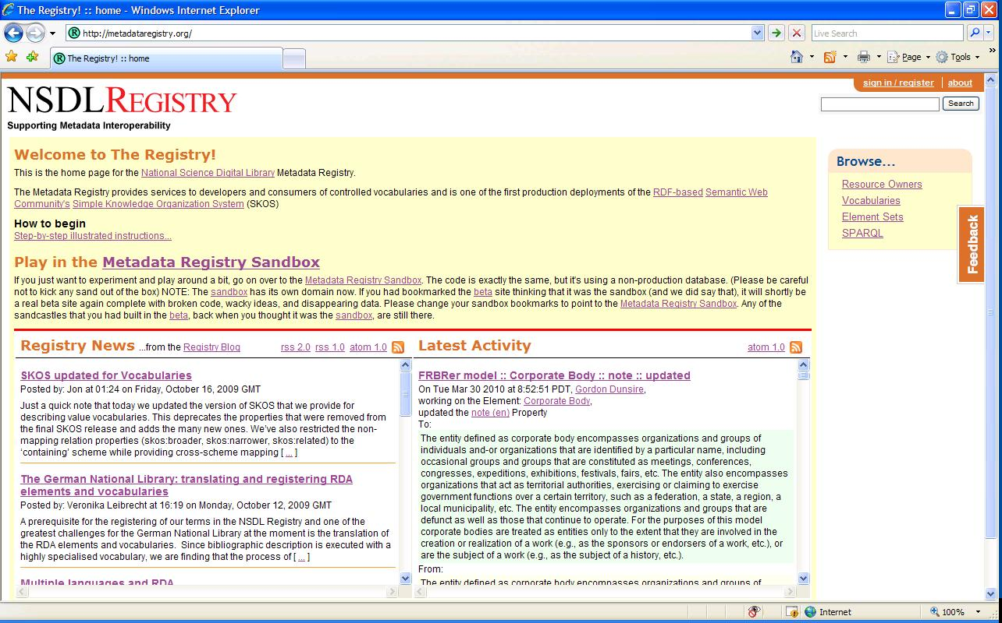

While this system uses the word “registry”, most of the resources, and certainly the functionality provided, promotes the deposit of vocabularies and APs. It does not appear that existing vocabularies can be imported, but rather the concepts or elements must be entered one at a time and then related to one another. This approach, of course, ensures that the SKOS data model, including the assignment of unique URIs, is used, thereby, promoting the ultimate integration across resources. This would be a hindrance to many large resources that are already published. Notes suggest that work is underway to support import of schemes and schemas that are already published.

A SPARQL query screen is provided, but it is in the native SPARQL language and does not provide support for novice users. There do not appear to be any web services available.

Extensive support for versioning has been the focus of the NSDL Registry’s development efforts. Every change is tracked and time-stamped which allows a snapshot of a vocabulary at a particular point in time to be reproduced. This kind of functionality is particularly important when trying to blend collections from multiple sources which may use individual vocabularies. In addition, if vocabularies are integrated or mapped, it is important to know which version of a term has been mapped.

The NSDL maintains some distinctions between vocabularies and element sets. When a vocabulary is displayed, the user has the option to show the concepts. When an element set is selected, the elements tab appears. This approach provides a single look and feel across the two major types of content in the Registry, and where there are commonalities, such as with version and history, the same language is used. The detail or descriptive metadata pages are also very similar.

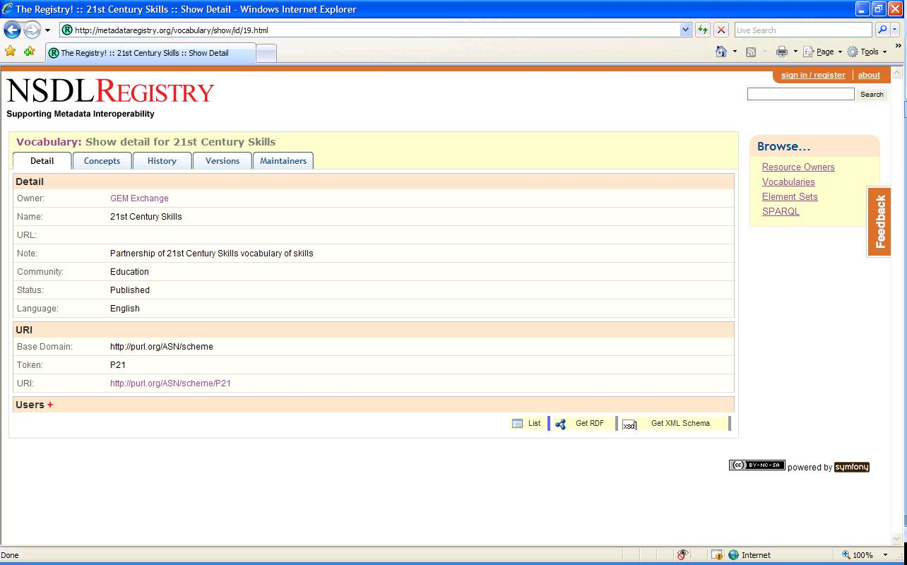

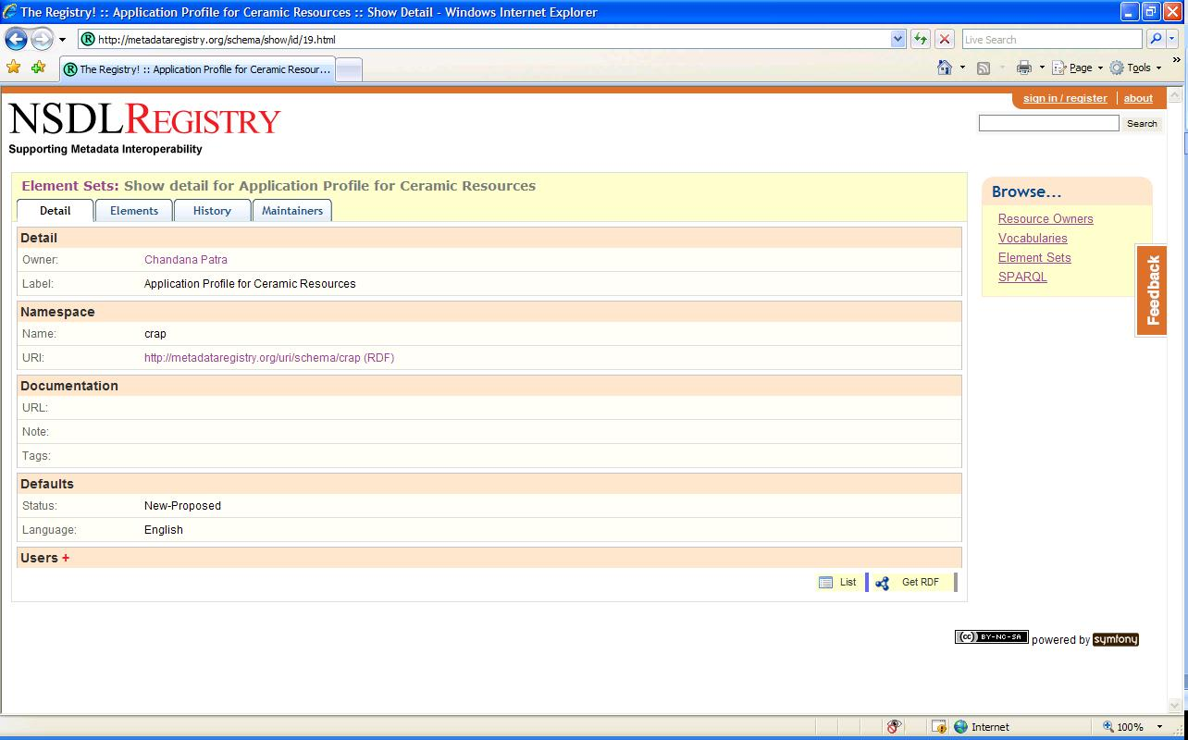

The code for the NSDL Registry is open source and available from the NSDL web site (http://trac.metadataregistry.org/wiki/InstallDocs). The Registry is one of the first production-level deployments of SKOS; SKOS is used as the common format for the registered vocabularies. The system is uses PHP and MySQL.
One of the major issues with the NSDL Registry is the fact that it is no longer supported by an NSF grant. Enhancements and maintenance must be supported by the registry community itself. However, it could serve as the basis for FAO development. The Creative Commons Attribution-Noncommercial-Share Alike 3.0 Unported License is used.

5.3 US Environmental Protection Agency Terminology Registry
The US Environmental Protection Agency piloted a Terminology Registry in the mid 1990’s. In 2005-2006, this pilot effort was migrated to a system supported by a commercial-off-the-shelf (COTS) tool called Synaptica from Synaptica LLC. The Terminology Registry is one of a series of registries available from the System of Registries (www.epa.gov/sor). The goal of the SOR is to provide standardization to support information exchange, data integration, promote understanding, and reduce the cost and time for development through the promotion of data standards and re-use.
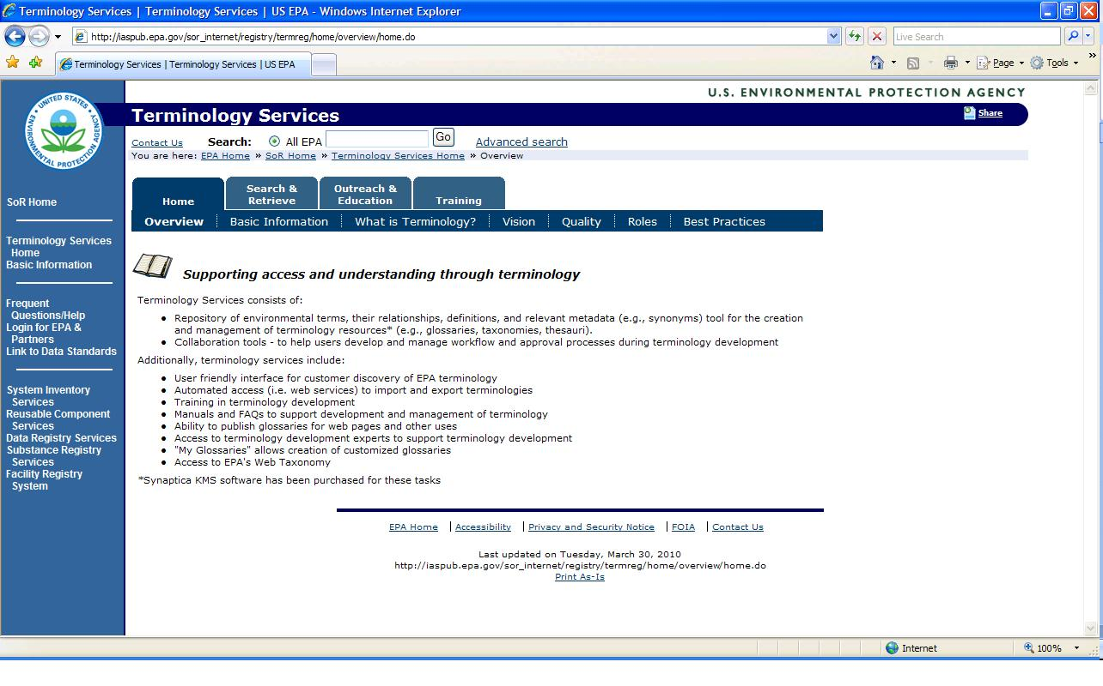
The Terminology Registry is both a registry and a repository. There is a registry that manages the vocabularies and the metadata about them. Then, each vocabulary is also ingested into the repository. The Terminology Services has the following components:
Many of the current services are based around the functionality provided by the Synaptica tool. Web services or APIs which came with the tool are available and used by groups within EPA and their systems to retrieve updated versions of vocabularies. For example, the Web Taxonomy is maintained in Synaptica but it is downloaded to a version compatible with the Documentum Web Content Management System for use in tagging web pages. The public interface to the content in Terminology Services was developed using the web services (APIs) that come with the Synaptica product.
Current functionality includes: vocabulary creation/maintenance and monitoring by vocabulary stewards; managing vocabulary development workflows, user accounts, and permissions, downloading whole vocabularies or parts of vocabularies, and specifically identifying acronyms and abbreviations.
One of the most beneficial functions is the ability to search for a term across all the vocabularies at the same time. Searching across the vocabularies in the repository is especially helpful when identifying how a term is used and whether the term has different definitions in different contexts. In this case, the context is set by the publishing organization and the name of the original vocabulary in which the term resides.
The ability to search across multiple vocabularies is also key to a function call MyGlossary. MyGlossary allows an individual user to select and then add terms and definitions in a personalized glossary that is saved under his/her e-mail address in the system. As the glossary develops, it can be shared with others and can, with approval of the Terminology Coordinator, be promoted to an enterprise-wide vocabulary.
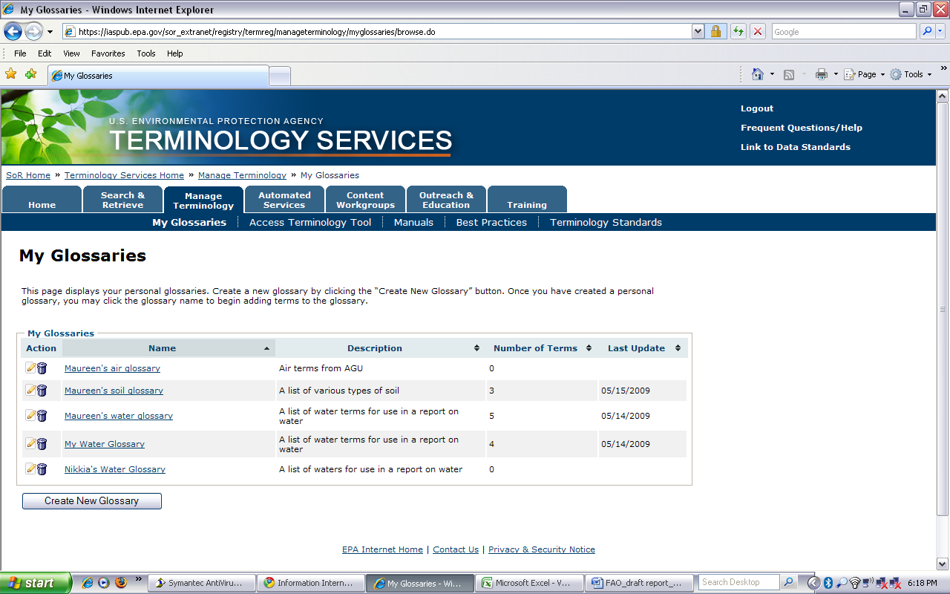
In addition, EPA is considering an extension to the MyGlossary function that would support MyProject Glossary development and collaborative glossary and definition formulation by inter-disciplinary project teams, development of a version of key vocabularies that can be loaded as an adjunct Microsoft customized spell check dictionary, and provision of a process and template for publishing glossaries to the web with a consistent EPA look and feel.
To support collaboration, the EPA Terminology Services Wiki was created for terminology development outside of the terminology tool Synaptica. The wiki is used to assist EPA programs and offices who are in the early stages of developing a vocabulary and need a tool that will allow collaborators to freely provide input and review contributions by others in a semi-structured environment. Other advantages to using a wiki include a solution to version control issues and built in documentation of the decision-making process. Terminologies can either be new or pulled from the Terminology Services repository for further development. Each term in a vocabulary has a “term page” and a linked “discussion page”. The term page displays the term’s current metadata, while the discussion page features the associated term’s metadata as the beginning of a discussion thread. Discussion participants reply to the thread with proposed changes to the metadata, with a special focus on developing collaboratively agreed upon definitions for terms. Term pages are revised, based on the discussion of the metadata, at the Steward’s discretion. The terminology can be transitioned into the Terminology Services using Synaptica for storage, maintenance and distribution by exporting the term pages and extracting the metadata from the text.

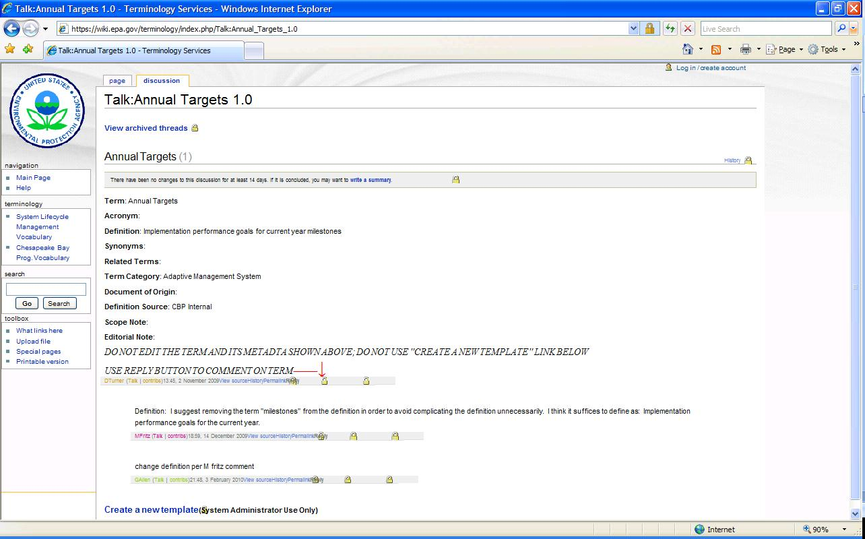

5.4 Global Biodiversity Information Facility
GBIF (www.gbif.org) is not a registry per se, but it does provide access to a number of vocabularies and data standards. It is primarily relevant because it seeks to provide an information management system across a widely distributed and heterogeneous network. However, it should be noted that while biodiversity is quite broad, it is actually much narrower in scope than agriculture, which incorporates areas of biodiversity as well as other disciplines.
GBIF is also included as an exemplar of how standards information can be organized. The standards, organism name vocabularies, application profiles, etc. are all closely linked to the GBIF architecture. From the architecture the main components, or major activities, can be identified: publishing, discovering, indexing, integrating, retrieving, and analyzing. The standards and tools enable the infrastructure to serve metadata, primary data, and organism name data.

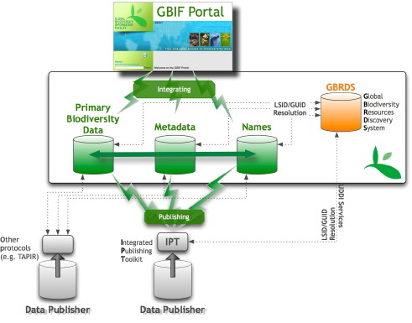
This is particularly apparent from Informatics page. The figure below shows the navigation and organization structure for Informatics – Standards and Tools.
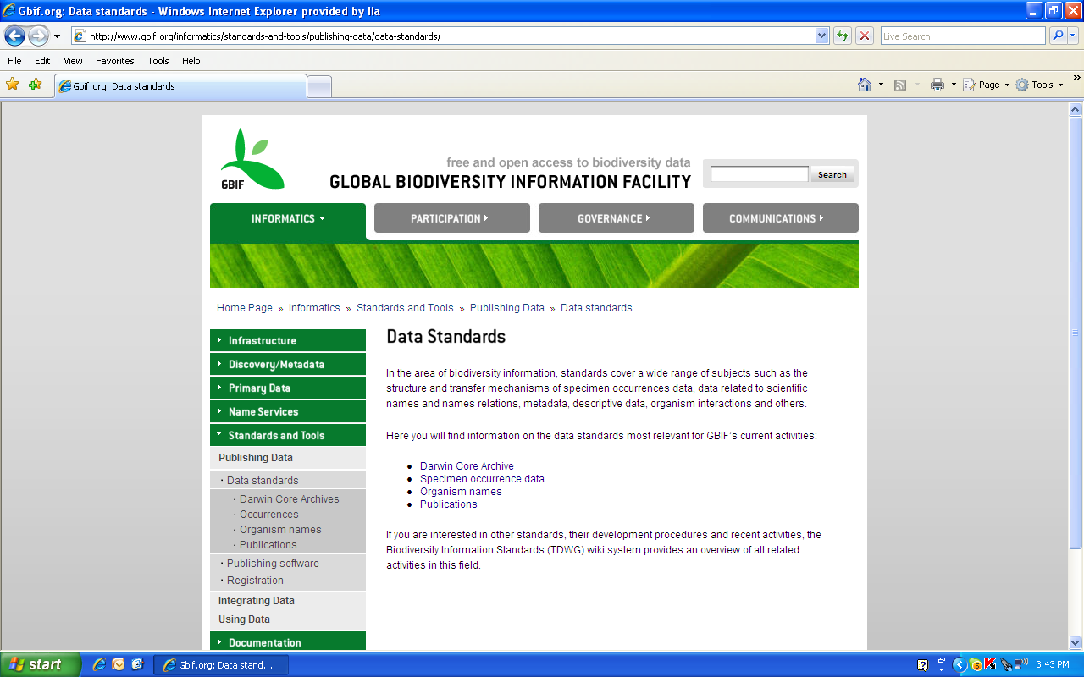

The organization of the links on the left navigation bar as based on activities to be performed by the user rather than the type of content. While this is used sporadically in the design of the AOS Registries (e.g., Developing APs), the organization is primarily by content type rather than by user task or activity.

5.5 OCLC Terminology Services
The OCLC Terminology Services (http://www.oclc.org/terminologies/default.htm) makes multiple terminologies available through a single interface. This project began in the OCLC Research Group and has since been made available to subscribers of OCLC’s Connexion and other OCLC cataloging services at no additional charge. The service now provides access to 9 vocabularies useful for cataloging such as LCSH, MeSH, the Canadian Subject Headings and the Thesaurus of Graphic Materials.
Terminologies are provided in several formats including MARC 21 format for authority data, ZThes, and SKOS, encoded in XML, RDF and JSON. The focus is on machine-to-machine processing, with the top-level site being dedicated to this purpose. All content is URI accessible with the following structure: the URL for the service/ the unique vocabulary abbreviation/ the unique identifier for the term/and the format requested (skos, zthes, etc.).
In addition, a human interface is available. The functionality includes a register of terminologies with brief metadata that can be viewed, cross-terminology search, and copy and paste into cataloging work forms. In addition to a human interface, there is an extensive machine-to-machine interface.
The addition of several new terminologies, access to complete term hierarchies, and additional mappings across terminology systems are in the development queue. According to a March 2010 article in the Code4Lib Journal, OCLC is seeking input from the library community regarding Terminology Services. The articles notes that WorldCat Terminology Services is still “an experimental research service with no service level assurances.” The LCSH content was also found to be outdated and OCLC has established a schedule for yearly or biennial updates of all vocabularies.

5.5 Library of Congress
The Library of Congress in the US has a history of providing name authority, subject heading and other controlled vocabulary files (KOSs) for the library community. Recently, the Library of Congress has begun to provide these resources from the LC Authorities and Vocabularies Service (http://id.loc.gov/authorities/about.html). Currently LCSH is the only vocabulary available, but there are plans to add other authority files. It should be noted that not all the details of LCSH relationships can be reflected in SKOS; the system currently includes over 300,000 authority records. Each vocabulary has a resolvable URI as does each data value (term) within the vocabulary. The full content or a specific concept record can be downloaded in RDF/XML or N-Triples.
In addition, a search interface has been provided. The figure below shows the results of a search on the word geography. The concept type and the unique ID (LCCN) are provided. Clicking on the link under Heading provides the terms record and its relationships.
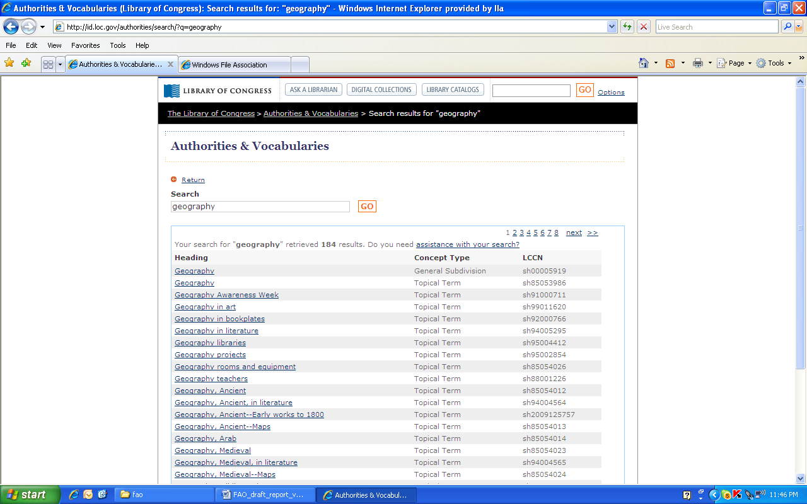
A unique feature of the Authorities and Vocabularies Service is the option from the term record to visualize the term and its relationships. For example, the diagram below results from requesting a visualization of the term Geography Projects.
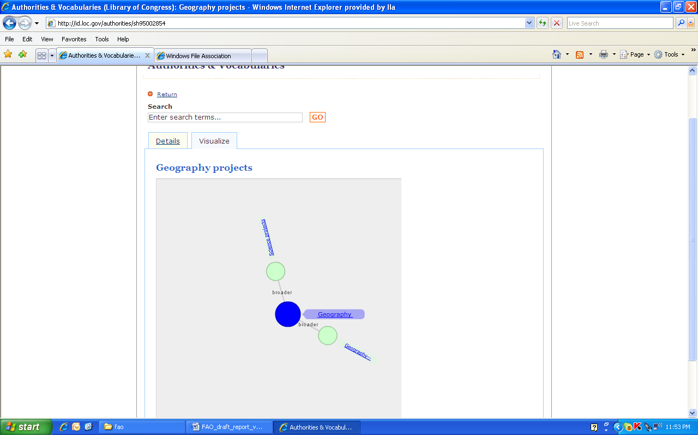
LC is also very interested in Linked Data (www.linkedata.org). Therefore, the Authorities and Vocabularies Service has linked its LCSH to the Rameau Project which provides French Subject Headings as linked data with resolvable URIs. LC has mapped concepts in the Authorities and Vocabularies Service to comparable Rameau concepts using the URIs.

6.0 Related Initiatives
In addition to the specific registries described above, there are several related initiatives that should be considered when assessing the current functionality and the future of the AOS. These are presented below.

6.1 JISC Terminology Registry
The impetus for the JISC studies used extensively in this report was the desire on the part of JISC to investigate the benefits of a Terminology Registry and associated services in the JISC context. Following the report to JISC……. [I’ve asked Doug Tudhope what the follow-up is to this project]

6.2 DC-NKOS Application Profile
The Dublin Core Metadata Initiative develops application profiles to extend or refine the DC metadata. There are application profiles for different content types and for different communities of interest (e.g., education). There is a new working group developing an AP for terminology resources. The goal is to identify the extensions or refinements to the DC vocabulary needed to adequately describe terminology resources of various types. This effort is directly related to the issues surrounding metadata for different KOS types and is bringing together experts from the JISC, NDSL, Ecoterm and other communities. [include some additional information from the proposal and an update on activities]

6.3 Ecoinformatics Ecoterm Working Group Efforts
The Ecoinformatics Ecoterm Working Group, of which FAO is a member, has been investigating ways to use and promote networked-based environmental terminologies. Ecoterm is made up of practitioners from various government and non-profit organizations who are interested in this topic. Several workshops have been held, including two hosted by FAO. Most recently Ecoterm has developed a wiki where there has been active discussion about the use of SKOS and voID files. To promote the effort there will be a central web site linking to these files. In addition, Ecoterm is identifying use cases for environmental terminology sharing and continuing to work on core and extended metadata for environmental KOSs which could be used as extensions to the Dublin Core-based voID metadata to accommodate terminology resources (see the DC-NKOS AP discussion in 6.2 above).

7.0 Vision for the AOS Registries [this section needs more work]
This section describes two visions for the AOS Registries. They are based on the assessment of the current AOS strengths and weaknesses, the comparison against other registries, and an eye toward the increased importance of semantics and meaning. In the latter, we discuss not only the semantic web but the impact of new non-text content such as datasets, images and multi-media. The first is a short-term vision that is more closely connected to the current state of the AOS Registries. The second is a longer-term vision.

7.1 Short-Term Future
The short-term vision is to provide more services based on the current registry structure. This approach continues the distinction between knowledge organization systems and application profiles. However, particularly in the case of the KOS Registry, it would provide services that rely on the actual content of the resources, requiring a concerted effort to provide direct or indirect access to actual vocabulary contents. This means either importing the vocabulary content (as a repository) or pointing to it through web services available from the native web site.
In the short term, it should be possible for owners to submit their KOS with metadata and in a limited number of formats. SKOS should be preferred. (It would also be advisable to identify a core set of relationship types that should be used.) The ability for owners to use the system to identify vocabularies or parts of vocabularies that they would want to re-use should be promoted. Importing the content raises issues of maintenance, version control and responsibility for quality. However, this approach has the advantage of increased flexibility to provide more services across multiple resources more easily.
The use of indirect web service calls may be feasible, but it will depend on the owners to develop these or to make the content available in a standard format such as SKOS against which an FAO application could interact. FAO may promote the availability of SKOS files by supporting the development of these SKOS files or by providing tools to allow the owners to more easily do the transforms and validate the resulting RDF/XML output.
Both for content from external sources and those held in the AOS Repository, web services would be available to access one or more vocabularies simultaneously. Publishing and promoting these web services will allow machine-to-machine use of the content of the KOS registry, facilitating a number of services noted above including search optimization, third-party metadata creation, and vocabulary integration.
APs can be handled in a similar fashion. However, for APs a service should be available to validate data that uses the AP against the AP itself.

7.2 Longer-Term Future
The longer-term future seeks to take full advantage of both the APs and the terminologies/ontologies. This is particularly powerful when dealing with data. In the data context, the APs reflect the data dictionaries and the terminology/ontologies are the value domains or classifications for the data elements that enable better understanding of the data. The longer-term future brings the APs and the terminologies/ontologies together into a similar structure so that they can more easily be connected. The concepts in the ontologies can be used to classify and describe the elements of the APs.
The GBIF Infrastructure is an exemplar of this approach. The name files, application profiles for data, and other standards and tools are closely linked to the functionality to be performed by the network. The network does not just point to tools and standards, but it utilizes them and shows how they support the functions and components of the network architecture.
Since it is unlikely that the heterogeneous world of agriculture will be able to standardize on a single terminology system, another vision for the longer-term future would be a BioPortal-like repository of content that provides tools and services to compare, merge, and annotate the ontologies. It should also be possible for resources to be submitted easily to this repository and for mappings to be stored.

8.0 Recommendations [this needs to be reorganized around section 7.0 and next steps]
This section provides recommendations for FAO consideration.

8.1 Establish a Clear Distinction Between the Repository and the Registry
One of the issues to be addressed by the AOS is how to marry services for those KOSs that are deposited (i.e., for which the AOS serves as a repository) with those for which it is only a pointer (i.e., where the KOS itself is available from another web site). While

8.2 Establish Web Services at the Vocabulary and Term Levels
Establish web services at both the vocabulary and the term level. These web services could be used to support the connection between other systems (both internal and external) and the content in the AOS. Web Services are most viable for content that is hosted in the AOS repository. However, if web services are available to the content on the publisher’s site, these could be provided as well. Publishers such as the European Environment Agency’s GEMET publish their web services for others to use. While web services generally do not change, they may be enhanced, so there is a need to provide for some level of review and maintenance to keep this kind of functionality current.
Appendix A outlines the web services from two systems, the NCBO BioPortal and the EPA Terminology Services. The NCBO BioPortal provides more detailed services, while the EPA services are more parameter driven. The EPA services are also constrained by the functionality of the Synaptica system itself. In both cases, as functionality is added to the main system, they are expressed in web services allowing for machine-to-machine access.

8.3 Extend the RSS Feed to the Term Level
The use of an RSS Feed is a relatively simple way to alert users to changes in the AOS content, and, therefore, to remind them of the existence of the AOS. The current AOS provides an RSS feed at the resource level, i.e., you can sign up to receive information only about all resources so the user receives information only when a new resource is added, one is deleted or a new version is added. The user should be able to select an RSS feed at the level of the addition of a new or revised AP or ontology to the AOS or a change or addition to content within a specific AP or ontology. It should be possible to select one or more APs or ontologies to monitor from the RSS setup rather than all.
Resources that are linked to from the AOS, rather than held in the repository, may have RSS feeds at the term level. Federating these RSS feeds can provide a single source for users to be alerted to changes in agricultural and agriculture-related vocabularies of interest to them. This type of federation has been done by the Department of Energy’s Office of Scientific and Technical Information for RSS feeds (in this case for science news) across the agencies who belong to the Science.gov Alliance (see www.science.gov).

8.4 Arrange for Search Engines to Index the AOS Content
Another relatively simple way to encourage use of the content is to allow Google and other search engines to index it at the content level. This is most easily done by creating an appropriate site map. This allows the AOS Managers to more easily control what is indexed and makes the effort more efficient and effective. There is still the need to be concerned about vocabularies that are not owned by AOS (permission should be received from the owner/copyright holder) and system performance must be guarded from the indexing robots.

8.5 Enable Linked Open Data and voID Files
As the linked open data approach to the semantic web takes hold, it may be advantageous to semantically-enable the use of these vocabularies in the linked open data environment. This involves the creation of RDF versions of the APs or ontologies. For simple thesauri and classification schemes SKOS may suffice. For those with more complex structures and robust expressive relationship types, RDF/OWL is likely to be the more appropriate to retain the level of content.
Announcing the available of these open data files is also important. A new technique from the W3C called voID is an RDF “header” structure that provides core metadata to describe an RDF resource. Core elements include name, publishing organization, host URL, etc. In addition, groups such as the DC-NKOS and Ecoterm have been working on identifying additional metadata that should extend the core elements to better describe KOSs.
Since many of the resources in the AOS are pointed to and not deposited, the full benefit of linked open data cannot be realized without a partnership with the publishers. FAO should provide support for and perhaps transform tools to aid partners in preparing and publishing standard RDF versions of their resources and equivalent voID files. The voID files could be linked to from the Ecoterm voID page which is being planned.

8.6 Affiliate the AOS with Other Registries
While the AOS Registry is well known, especially in the agriculture and environmental communities, its current structure does not allow it to be easily affiliated with other registries. FAO should work with Ecoterm, BioPortal and the Open Ontology Repository to determine what affiliation might be feasible.

8.7 Use Open Source Software
One option that may allow for increased visibility, use and functionality would be to replace the current AOS with an open source ontology registry. The most prominent open source ontology registry software at this time is BioPortal which is being used by the genetics and biotechnology communities. The use of open source software has the advantage of moving the burden of development and software maintenance from FAO to the developers and a larger community. The majority of the new web services and functionality discussed here may be available “out of the box” in the open source environment. This approach will allow FAO to focus on the development and acquisition of content, and the promotion of the APs and ontologies.
Alternatively, FAO could host an instance of the BioPortal. This approach would allow FAO to use the base software but to continue to build services and tools to meet the specific needs of the FAO and its partners. As noted above, an instance of BioPortal has been installed by the Marine Metadata Initiative (MMI) where it has been enhanced, and it is being considered for deployment by the Ecoinformatics International Collaboration to register environmental ontologies.
If FAO chooses to host its own instance of open source ontology software, it must consider how to maintain alignment with the other open ontology repositories/registries so that functionality can be easily migrated to the FAO instance as the open source development community enhances the software. Ultimately, federated access across these various repositories will be beneficial, linking the agriculture community to other related science communities.

8.8 Provide Collaboration Tools and Services
FAO provides a Tool Registry as part of the AIMS web site. There are a number of tools and services that could be provided to support the development of additional ontologies and APs. These might include a terminology wiki to support collaborative AP and ontology development, publishing templates to support the publication of common types of KOSs to the Web or in document form, tools for comparing two vocabularies, tools for mapping (including the use of the SKOS mapping language), and tools for managing relationship types across the community.

8.9 Perform Usability Testing for Both General Users and Developers
While working with the AOS, we identified some issues related to the general navigation, layout and help text provided. Here are some areas that we think could benefit from some attention:
- On the KOS selection, it is possible to go back to All topics, but it doesn’t appear to be possible to go back to all types without using the back button or going out of the page and reentering.

9.0 Next Steps

APPENDIX A: Web Services

Web Services from BioPortal
- Services to access ontologies and ontology versions
  - 4.1 List all the latest version of ontologies
  - 4.2 Get a specific ontology based on a version id
  - 4.3 Download an ontology file
  - 4.4 Download the latest ontology file
  - 4.5 Get all versions of an ontology from a virtual ontology id
  - 4.6 Get latest version of an ontology id
  - 4.7 List all ontology categories
  - 4.8 List all ontology groups
- Services to access ontology views and ontology view versions
  - 5.1 List all the latest version of views
  - 5.2 Get all versions of views from a virtual ontology id
- Search services
  - 6.1 Search BioPortal
- Term services
  - 7.1 Get term
  - 7.2 Get all root terms for an ontology version id
  - 7.3 Get term for latest ontology version id
  - 7.4 Get all terms using the specific ontology version id
  - 7.5 Get all terms using the virtual ontology id
  - 7.6 Changes to the Get all terms service
- Instance Services
  - 8.1 Get an instance and its property/value pairs
- Hierarchy Services
  - 9.1 Get parents/children of a given concept in a specific ontology version
  - 9.2 Get parents/children of a given concept in the latest version of a given ontology
  - 9.3 Get paths to roots/leaves from a concept in a specific ontology version
  - 9.4 Get paths to root/leaves from a concept in the latest version of a given ontology
  - 9.5 Get siblings of a given concept in a specific ontology version
  - 9.6 Get siblings of a given concept in the latest version of a given ontology
- RDF Dump Service
- Bio2RDF Dump Service
- Annotator Service
- Resource Index Service
- Prototypes
  - 14.1 Notes Service
  - 14.2 Mapping Service
Web Services from EPA Terminology Services (Synaptica)

- Login – log in to the system
- Logout – log out of the system
• ListTaskviews – list the names of taskviews, which are collections of one or more vocabularies
• ListVocabularies – list the names of vocabularies
• ImportTerms – import terms into a vocabulary
• ExportVocabulary – export a vocabulary into a variety of formats
• ValidateTerms -
• ListRelatedTerms -
• GetSavedReport – execute a saved report
- SearchTerms – search for a term

APPENDIX B: Metadata Analysis

Insert Nikkia’s table here

References

Golub, K. & D. Tudhope. (Rev. March 2009) “Terminology Registry Scoping Study: Final Report.” Available: http://www.jisc.ac.uk/media/documents/programmes/sharedservices/trss-report-final.pdf [March 30, 2010]
D. Tudhope, T Koch & R. Heery. (2006) “Terminology Services and Technology: JISC State of the Art Review.” Available: http://www.ukoln.ac.uk/terminology/TSreview-jisc-final-Sept.html [March 30, 2010]
Networked Knowledge Organization Systems (NKOS). Available: http://nkos.slis.kent.edu/ [March 30, 2010]
Hodge, G. “Systems of Knowledge Organization for Digital Libraries: Beyond Traditional Authority Files.” Available: http://www.clir.org/pubs/reports/pub91/contents.html [March 30, 2010]

